**Group A**

**Lab 3B**

**Scala**

**Participants:**

**1. Aadarsha chapagain**

**2.Jyoti shukla**

**3.Rishi Phaneendra Varma**

**4.Priti Bhale**

**5.Sreya Treesa Johny**

**6.Piyush Bhatia**

**Slide 3:**

“ public int age();” is a getter (accessor method)

“public void age_$eq(int);” is a setter . _$eq means _equal to

public Person($iw); : constructor of the class

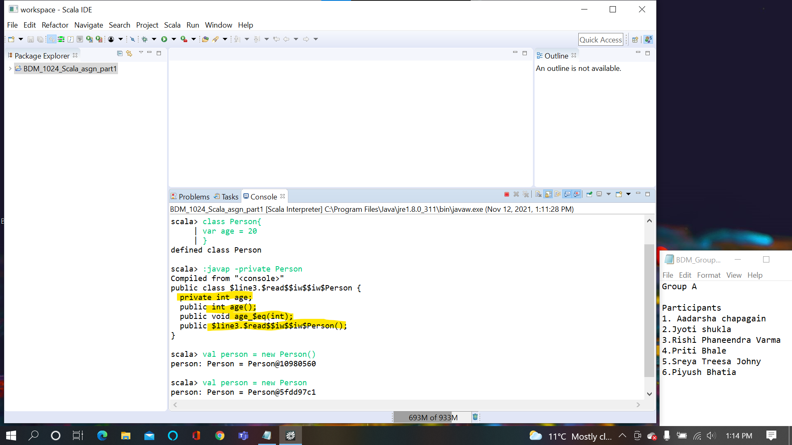

**Slide 4:**

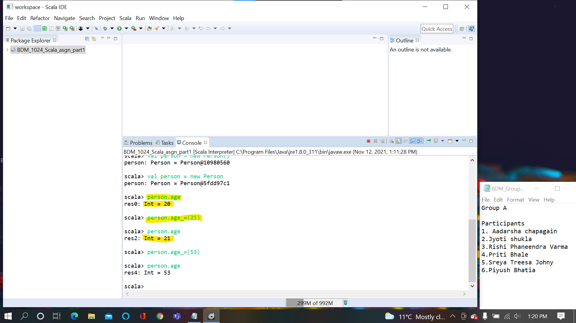

**Slide 5:**

Here the val is used so it won’t allow to set the variable so error is thrown

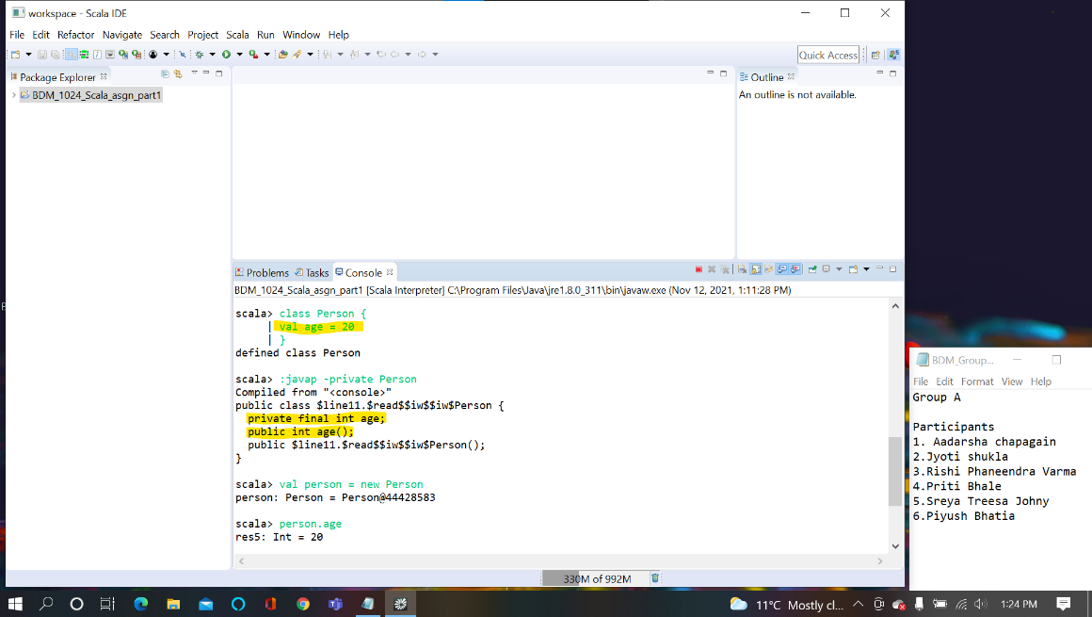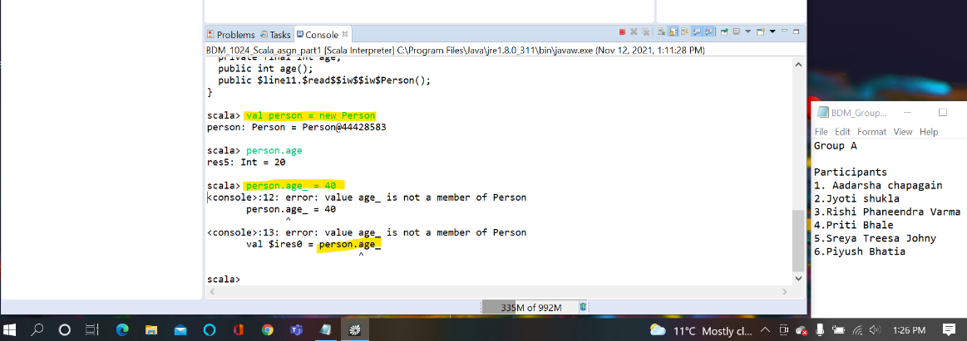

**Slide 6:**

We have written our own setter method with condition to set if the age lies between 0 to 100

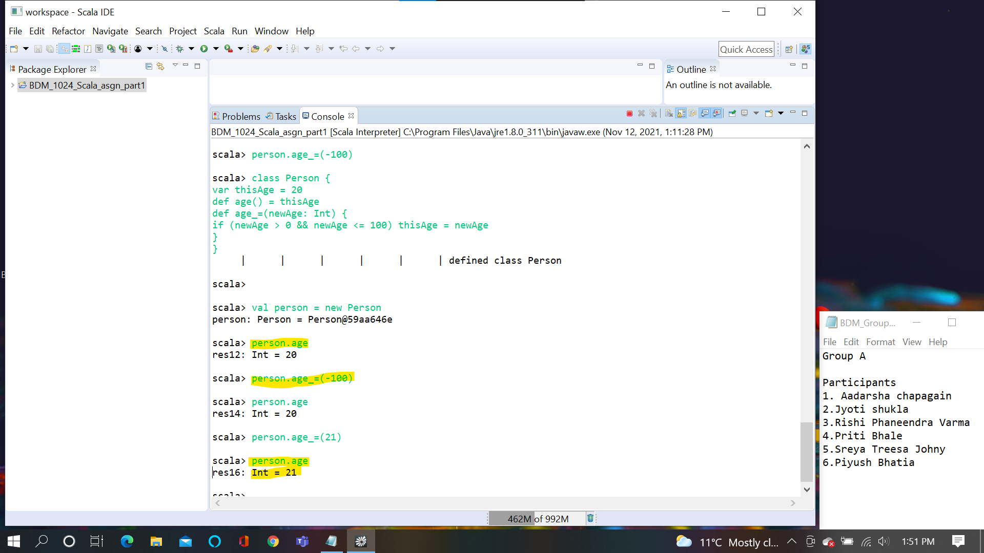

**Slide 7:**

Scala allows to use setter method even without parentheses.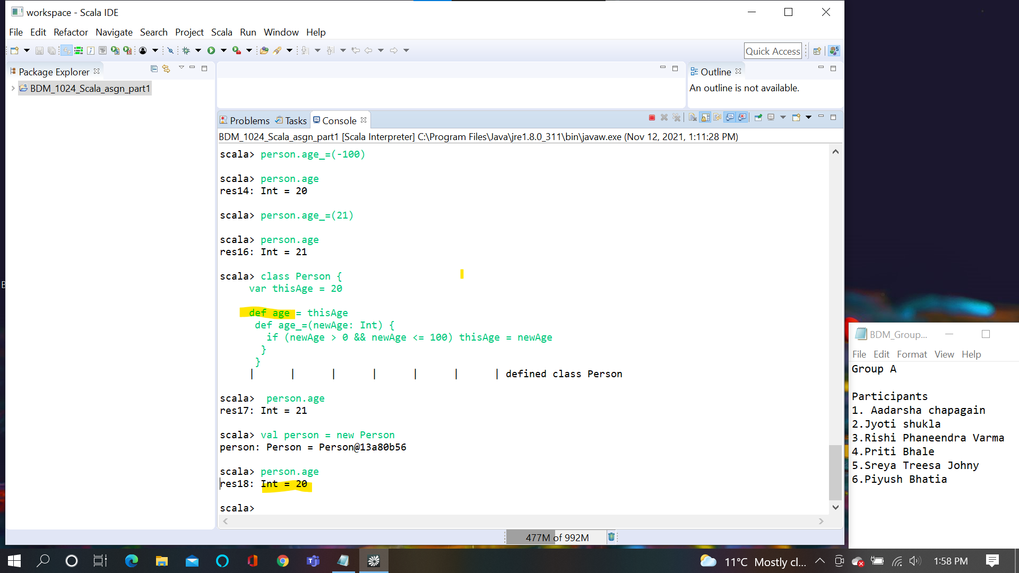

**Slide 8:**

Generate java time get and setter by using @BeansProperty

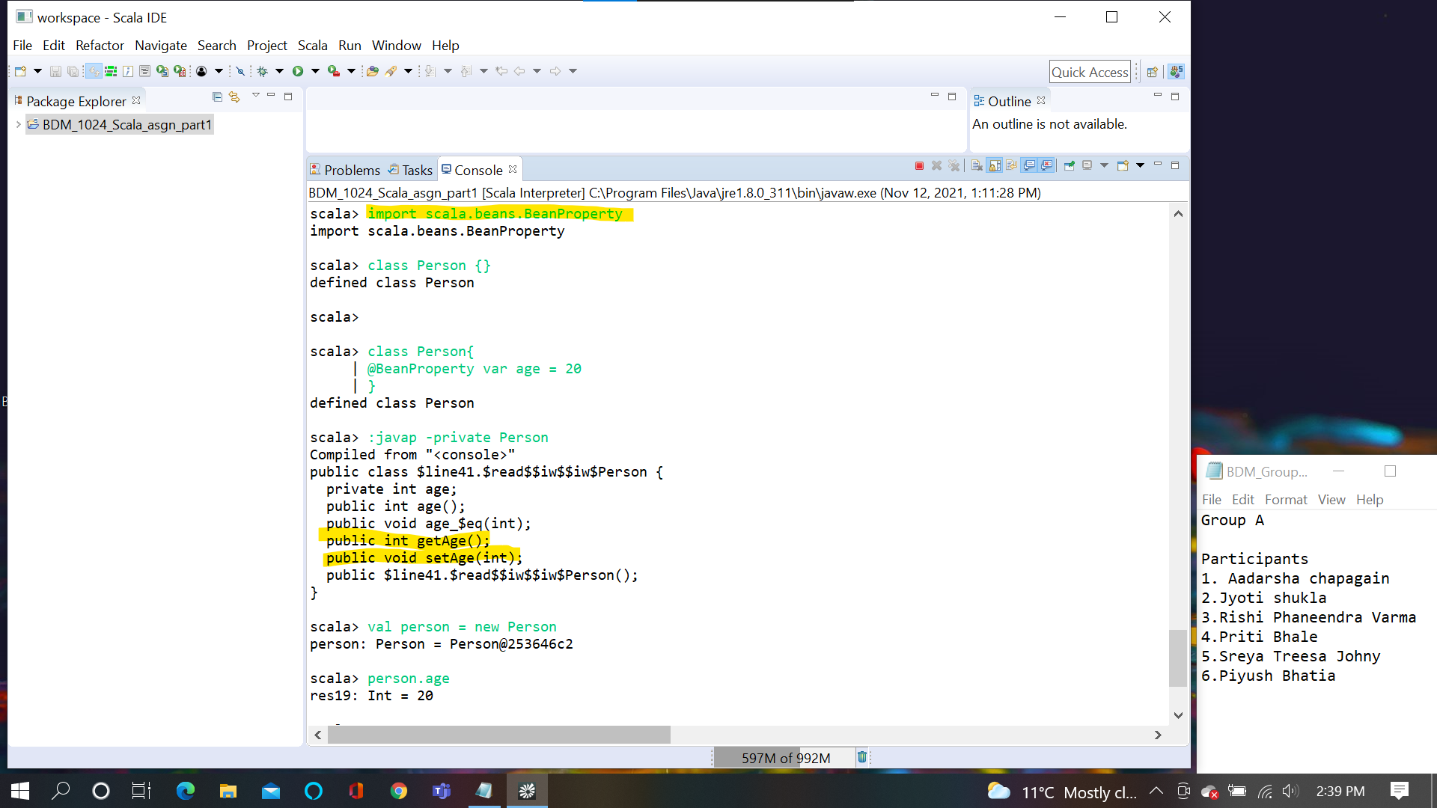

**Slide 9:**

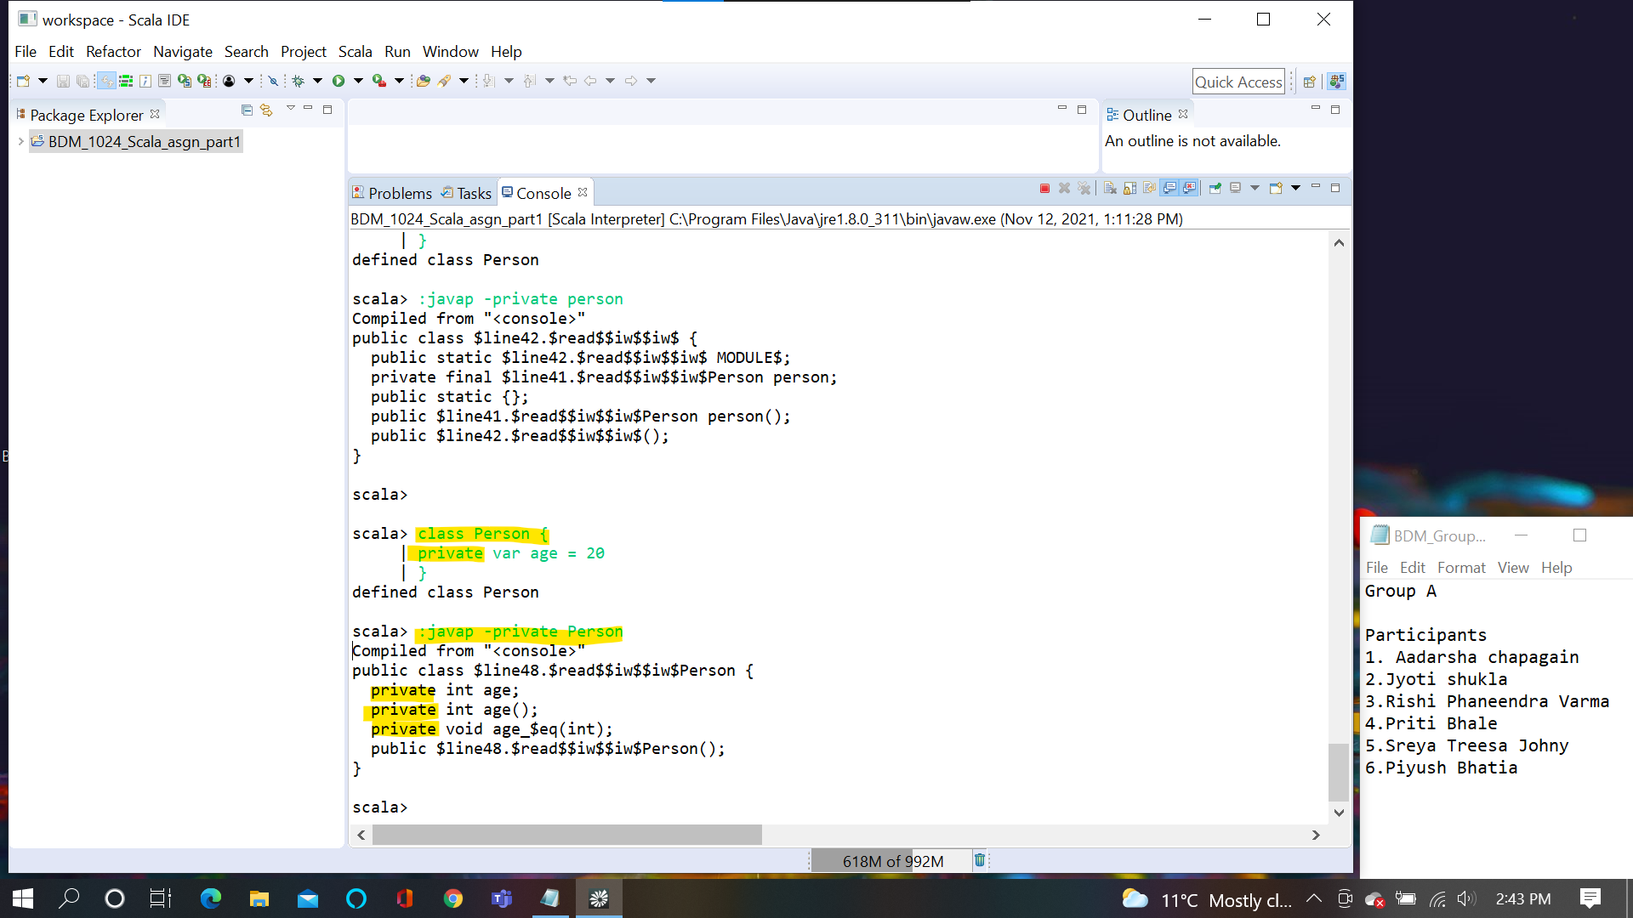

**Slide 10:**

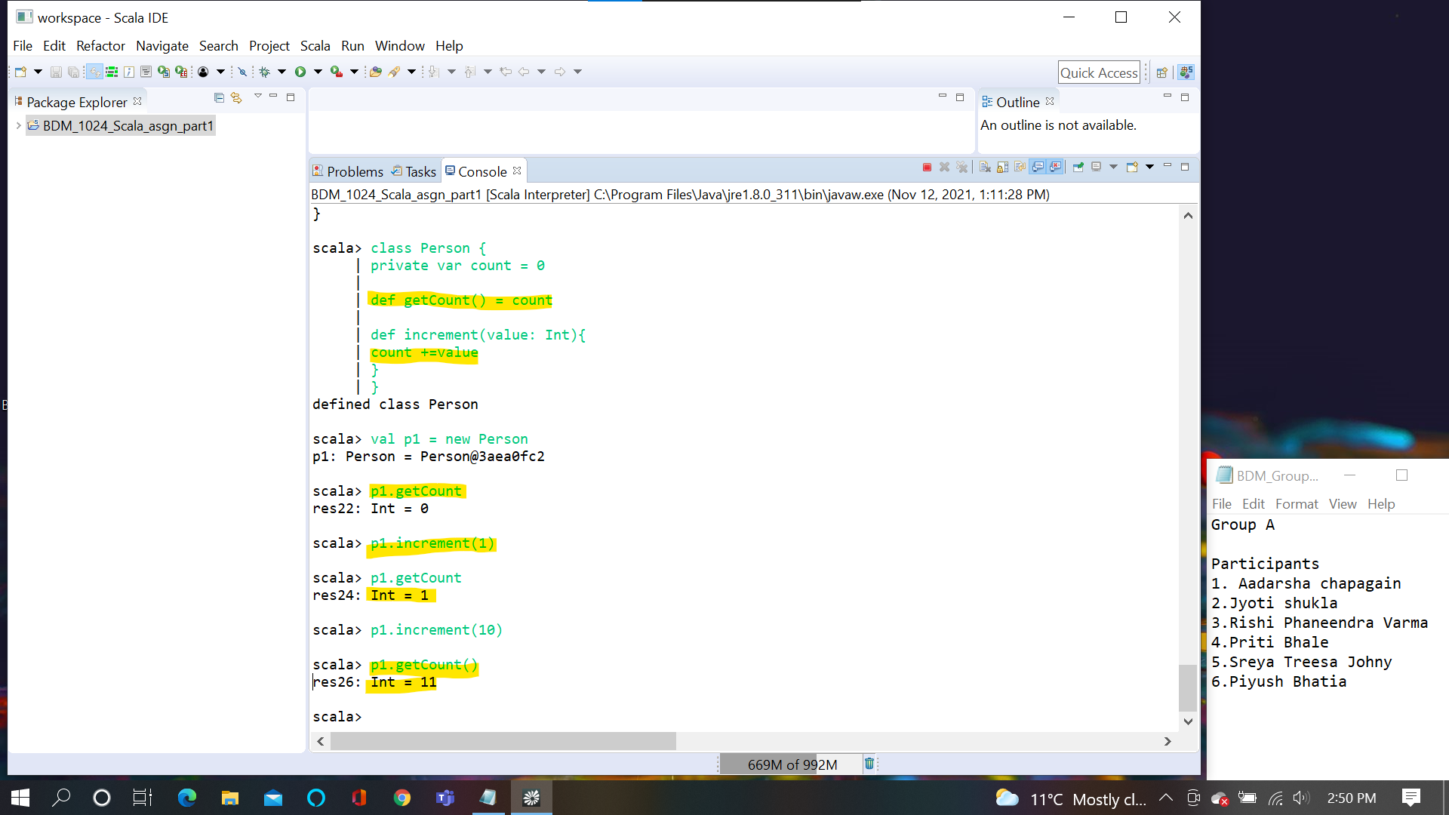

**Slide 11:**

Even if a particular attribute or variable in a class is private instances of the same class can refer to private variable directly because they are part of the class. Only when there is an object of another class then they are not able to refer to

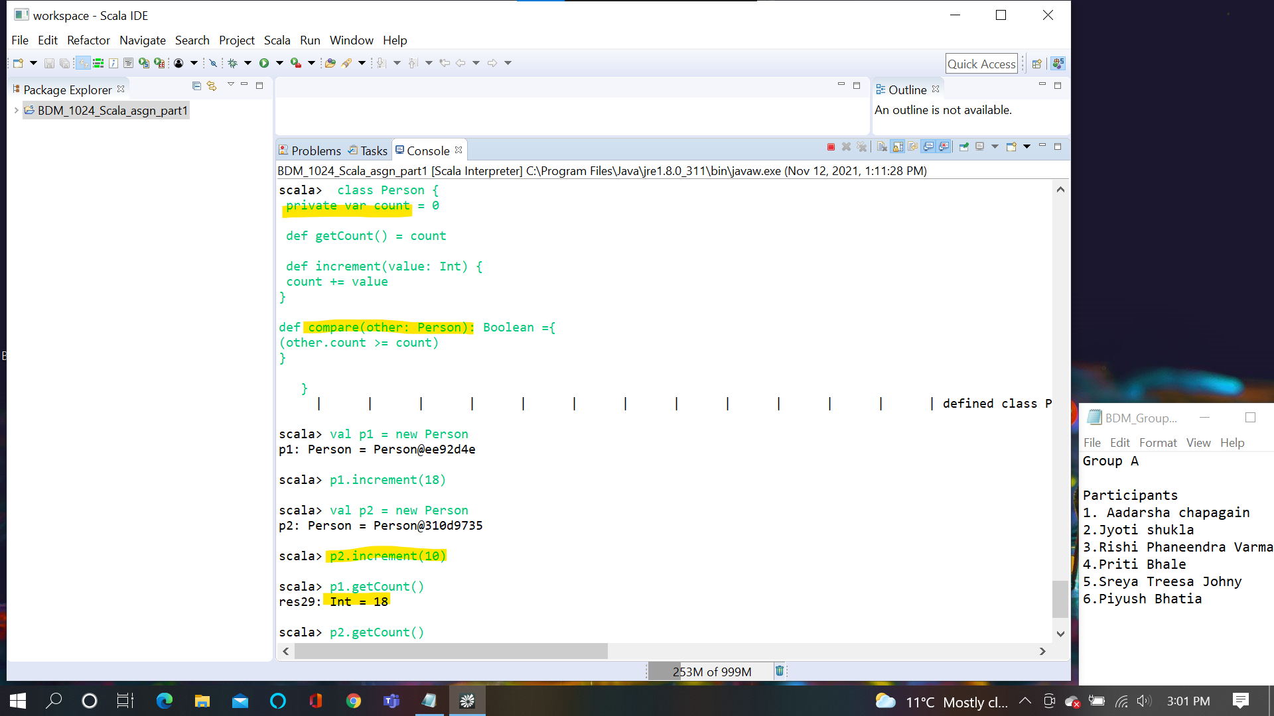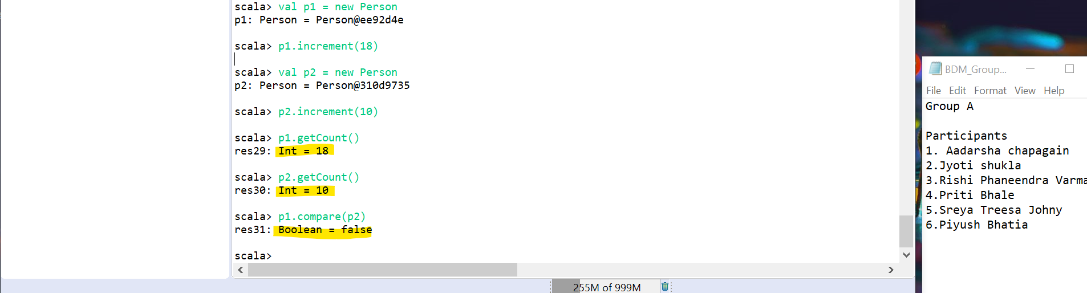

**Slide 12:**

private[this] var count “ means only available in the specific object either same class or different class

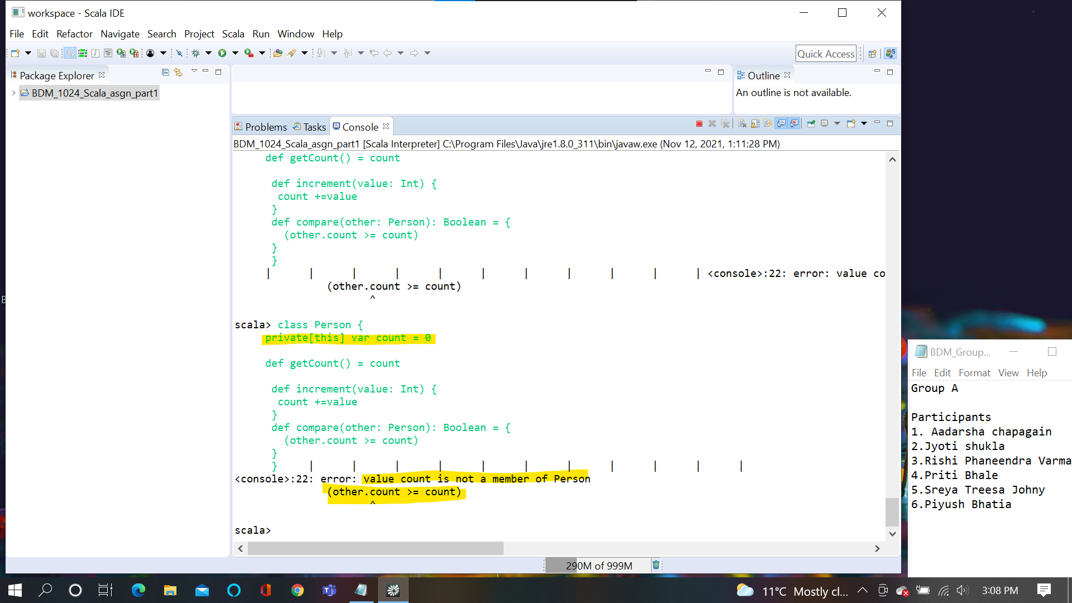

**Slide 13:**

Here the primary constructor is not specified so it takes the default constructor.

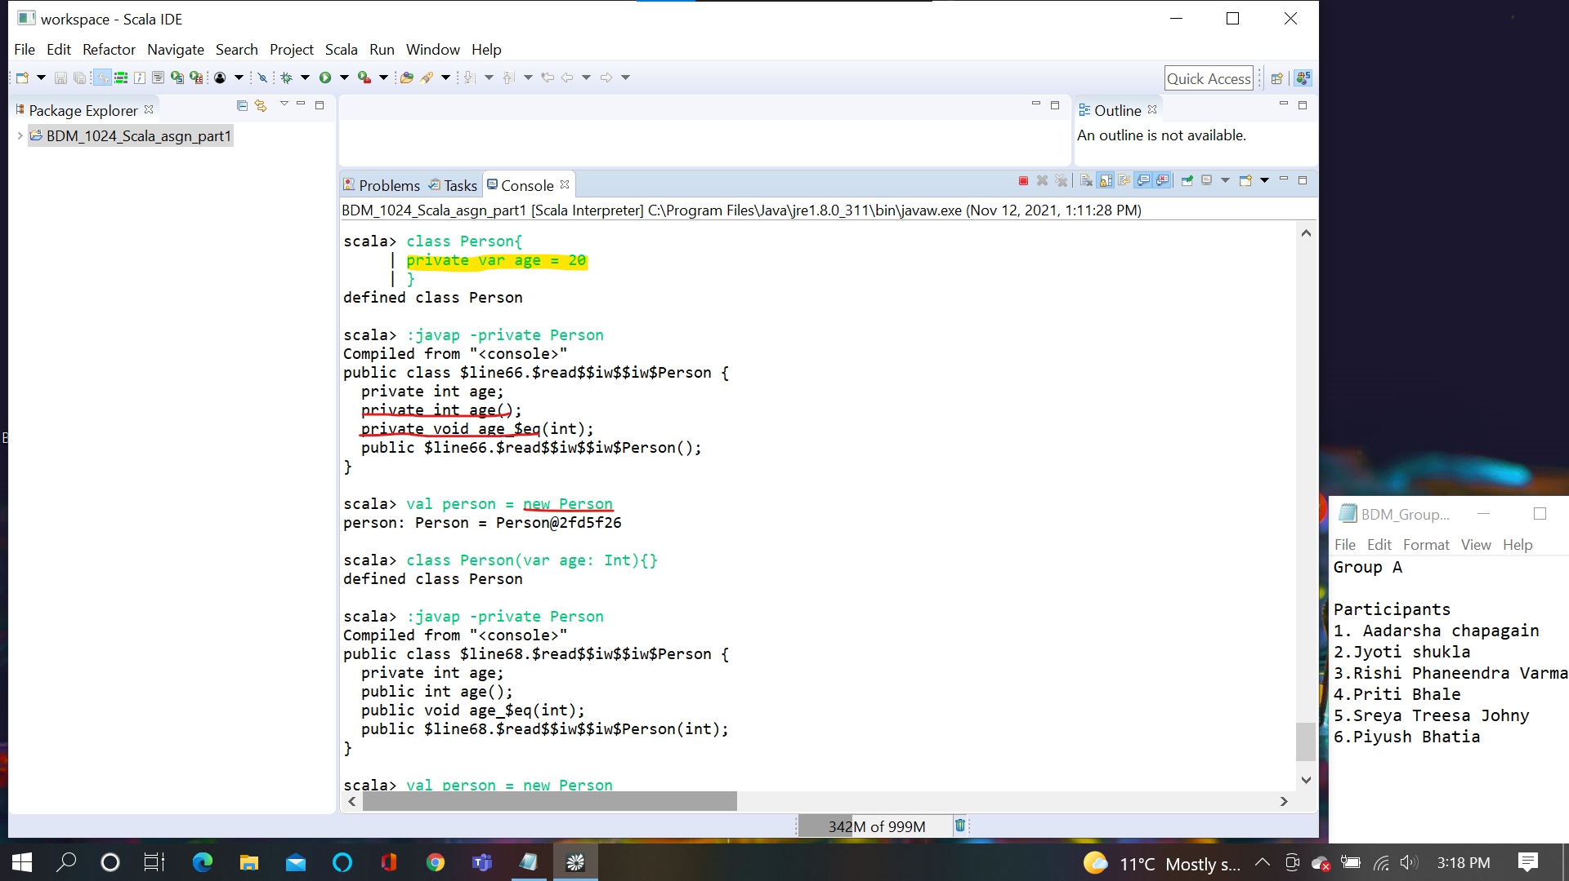

**Slide 14:**

Here we have specified the constructor so while we initialize without any argument it throws error.

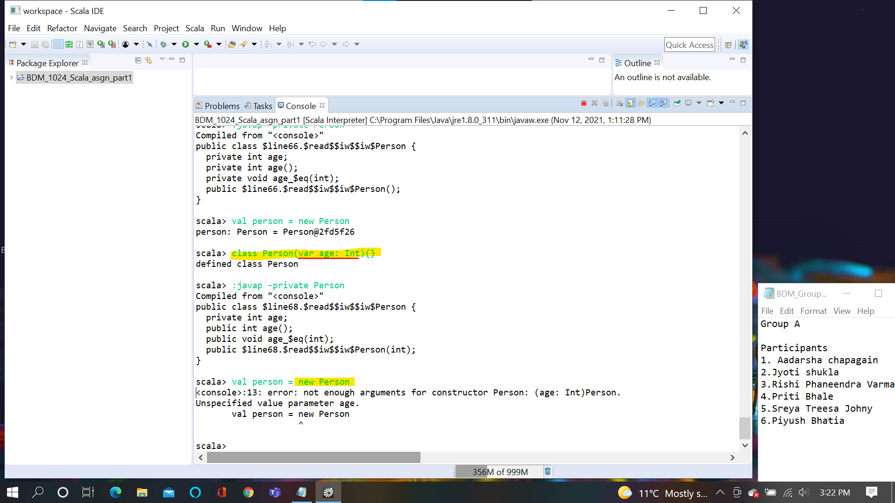

**Slide 15:**

Passing the argument(20 in this case) works. Since that is the argument the class is asking.

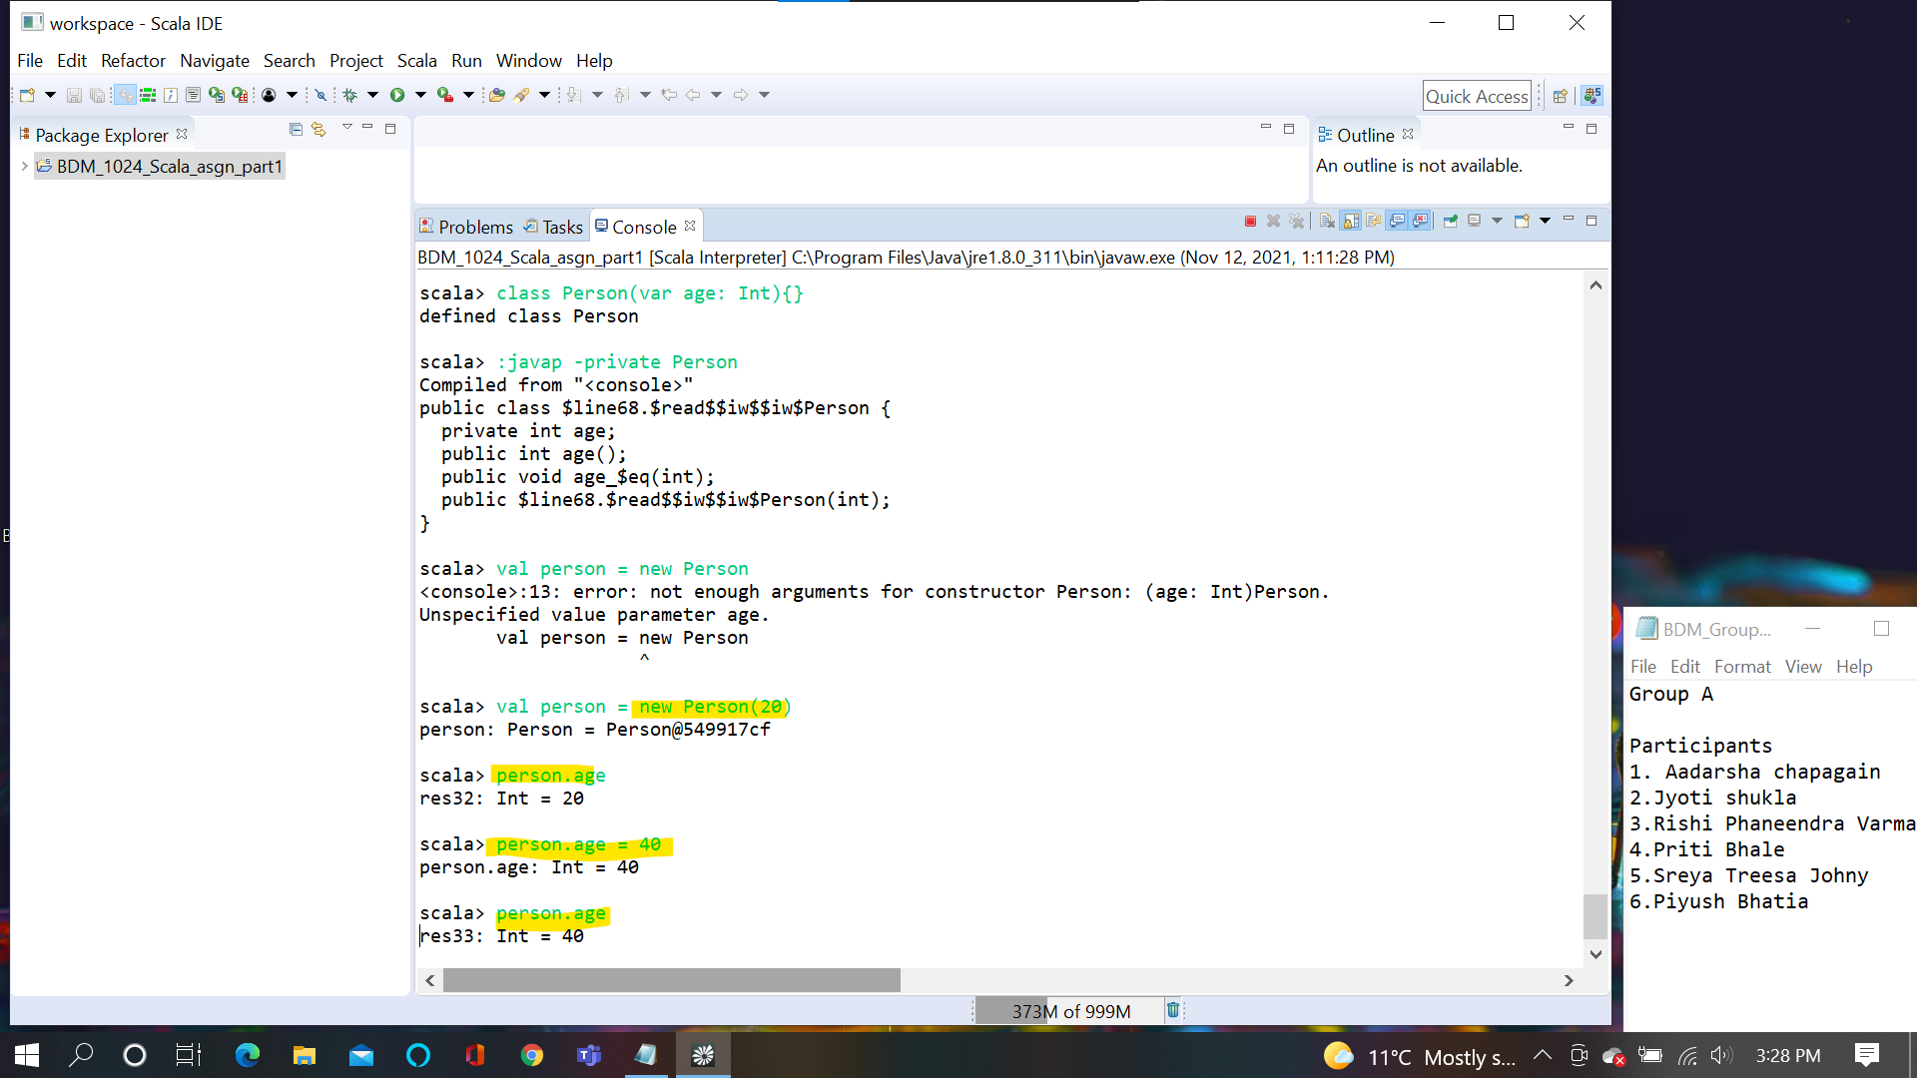

**Slide 16 and 17:**

If val is not specified it will not create any getter or setter method. If val is specified it will generate the getter method only.

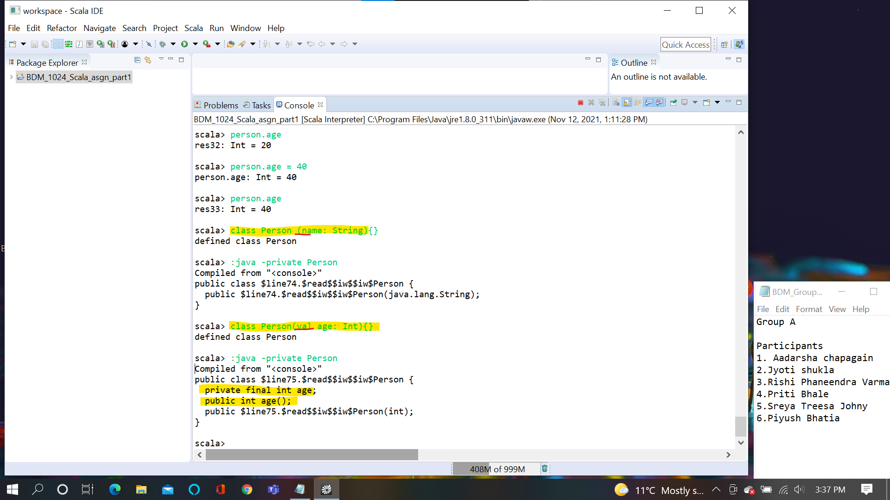

**Slide 18:**

When you define it as private.If it is val it will generates private getter but not setter.If it is var it will generate private getter and setter

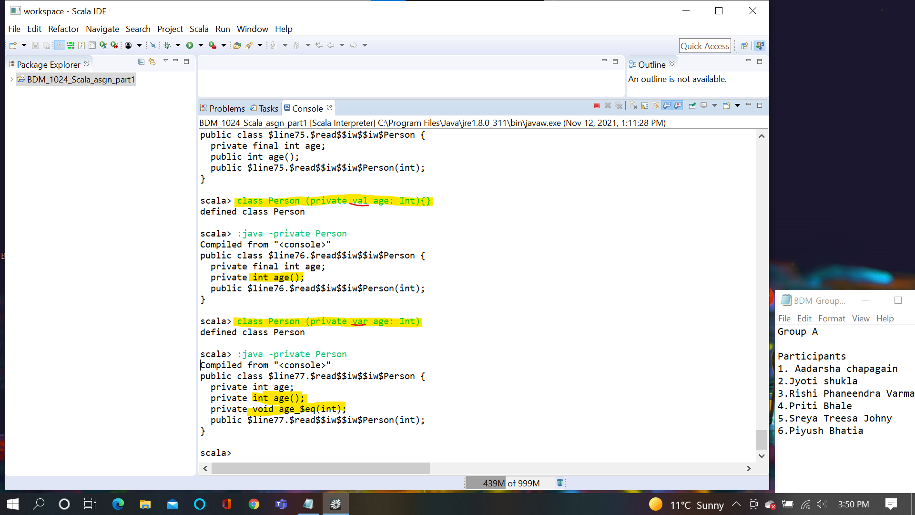

**Slide 19:**

When @BeanProperty is used it will generate java getter and setter for var

And getter javatype for val. @BeanProperty is meant for Java interoperability.

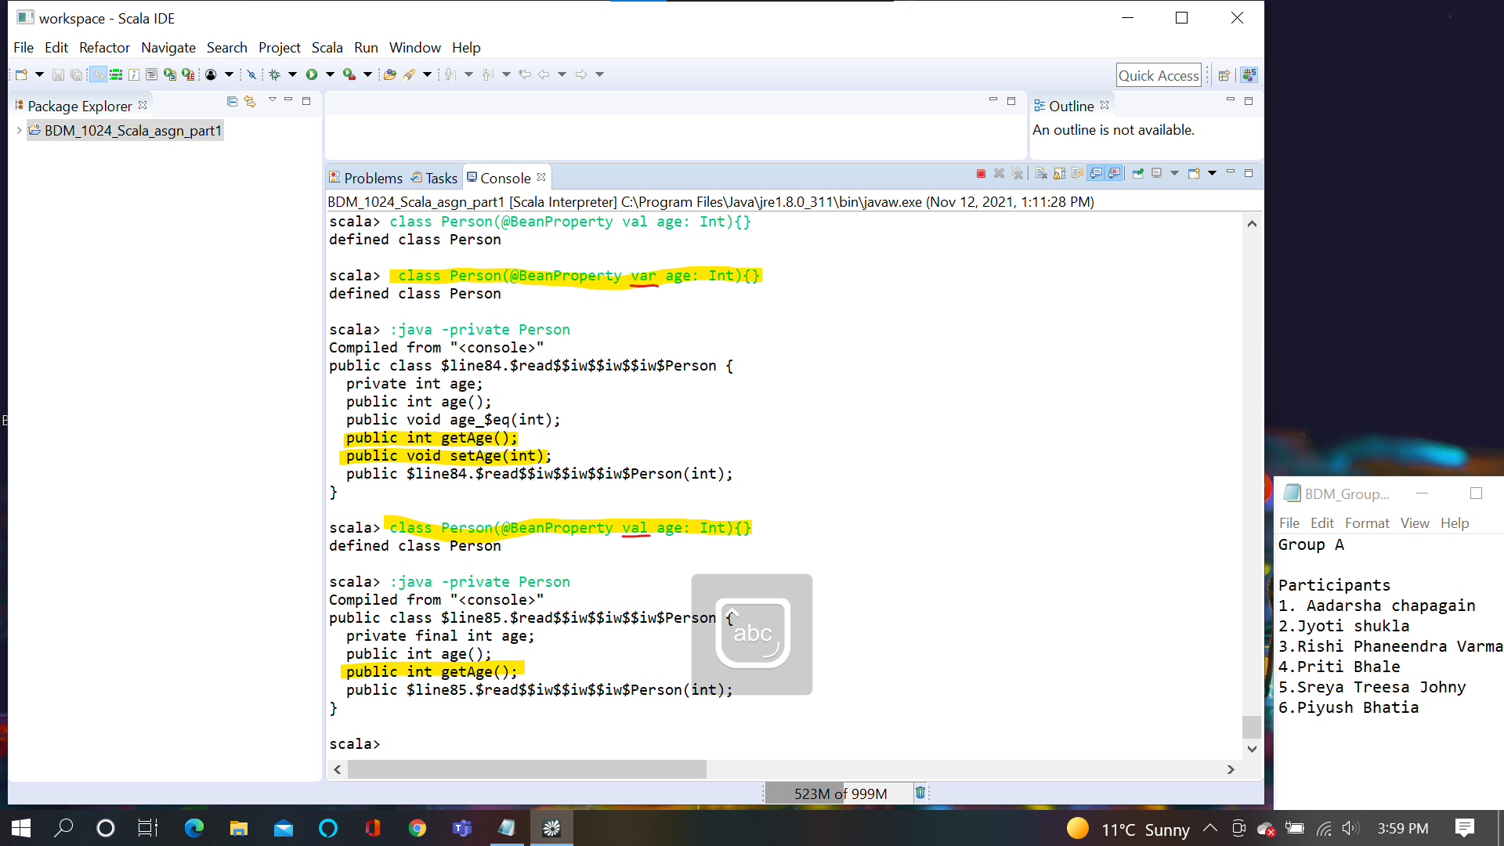

**Slide 20:**

When we use private [this] it will be only available with that object that’s why it does not generate getter and setter

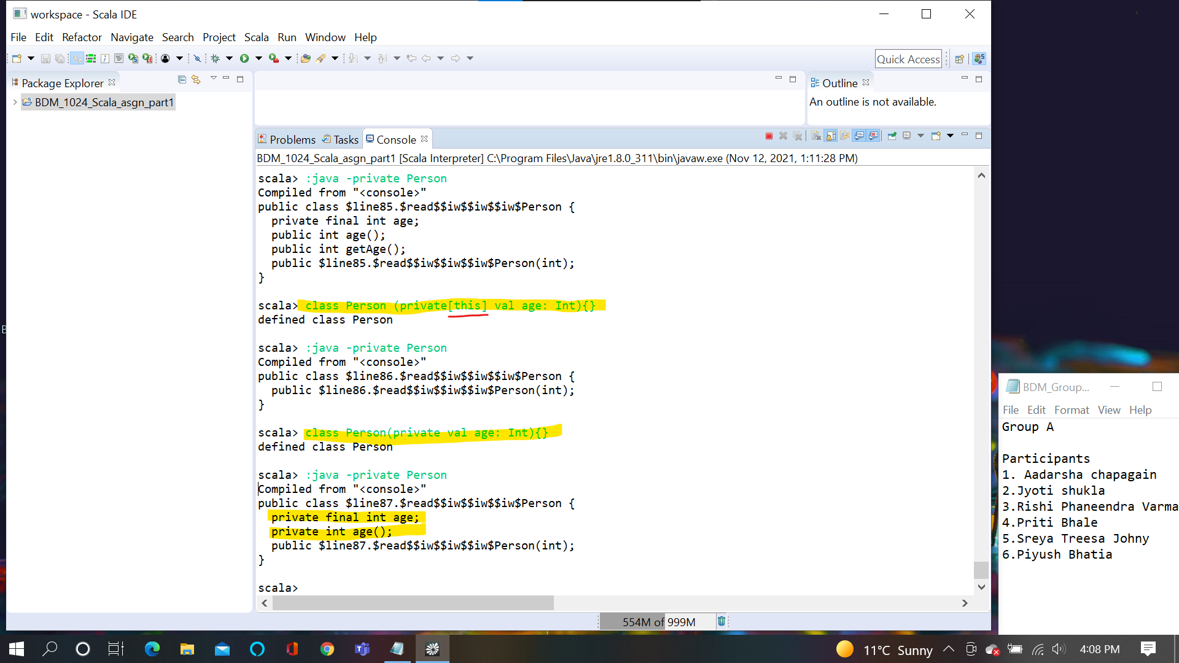

**Slide 21:**

In both classes variable “age”is defined but in the second one it is used within procedure however in the first one it is not used anywhere.

In the second one “age” is used in the procedure so, Variable become a class variable

If val or var is not used and the if the variable is not used anywhere it cannot be a class variable

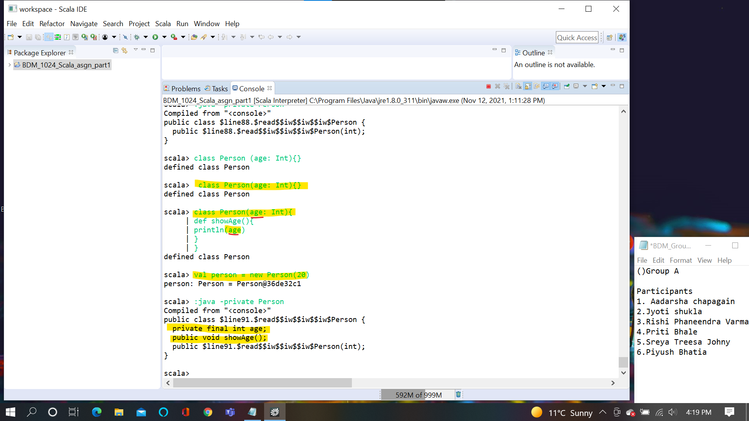

**Slide22:**

Anything that follows the definition of primary constructor within a class becomes a code which get executed when primary constructor executed

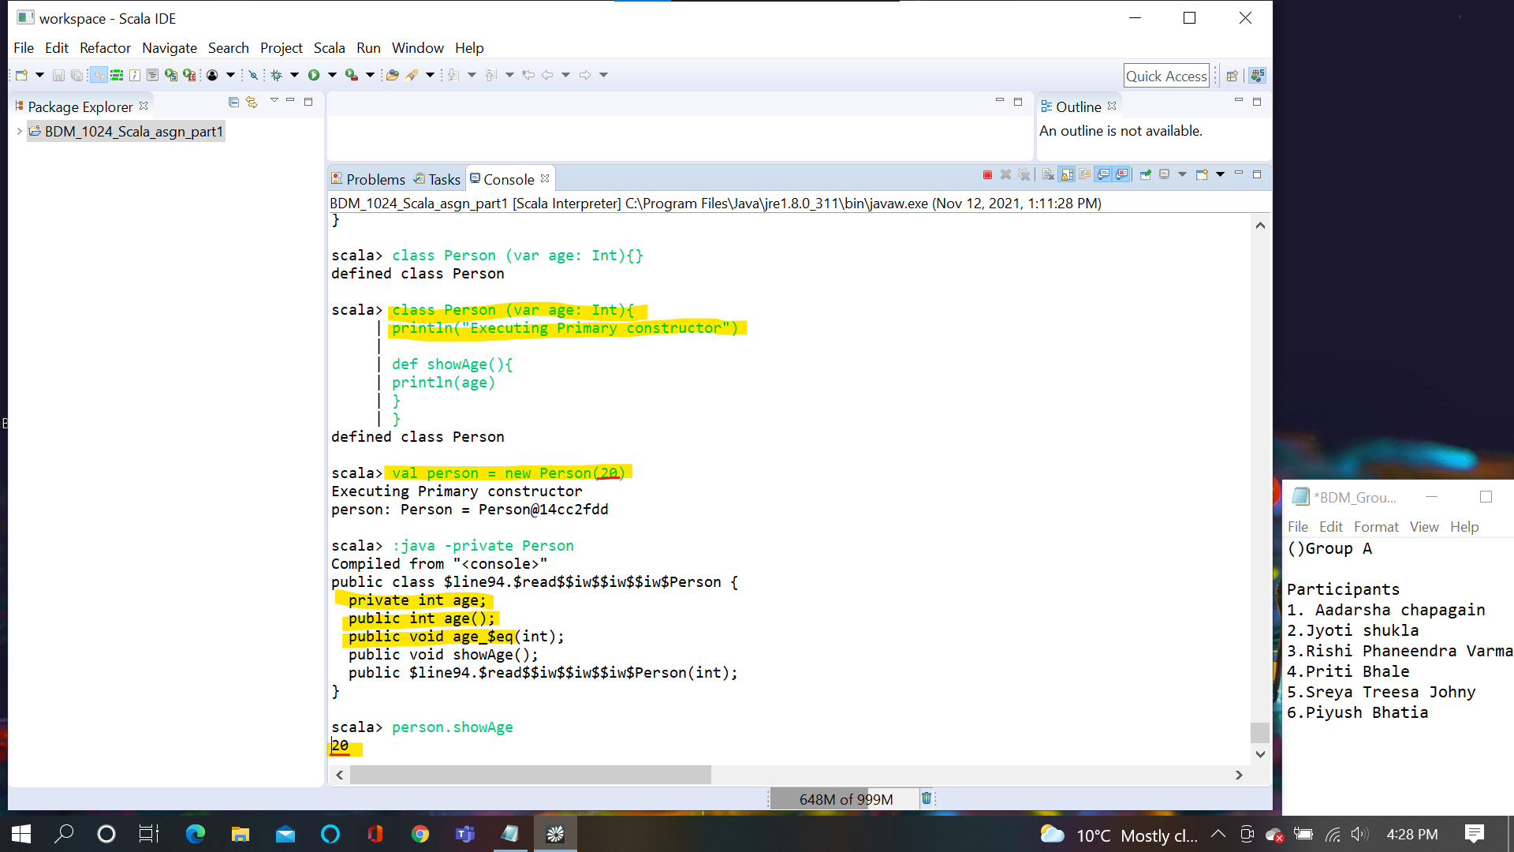

**Slide 23:**

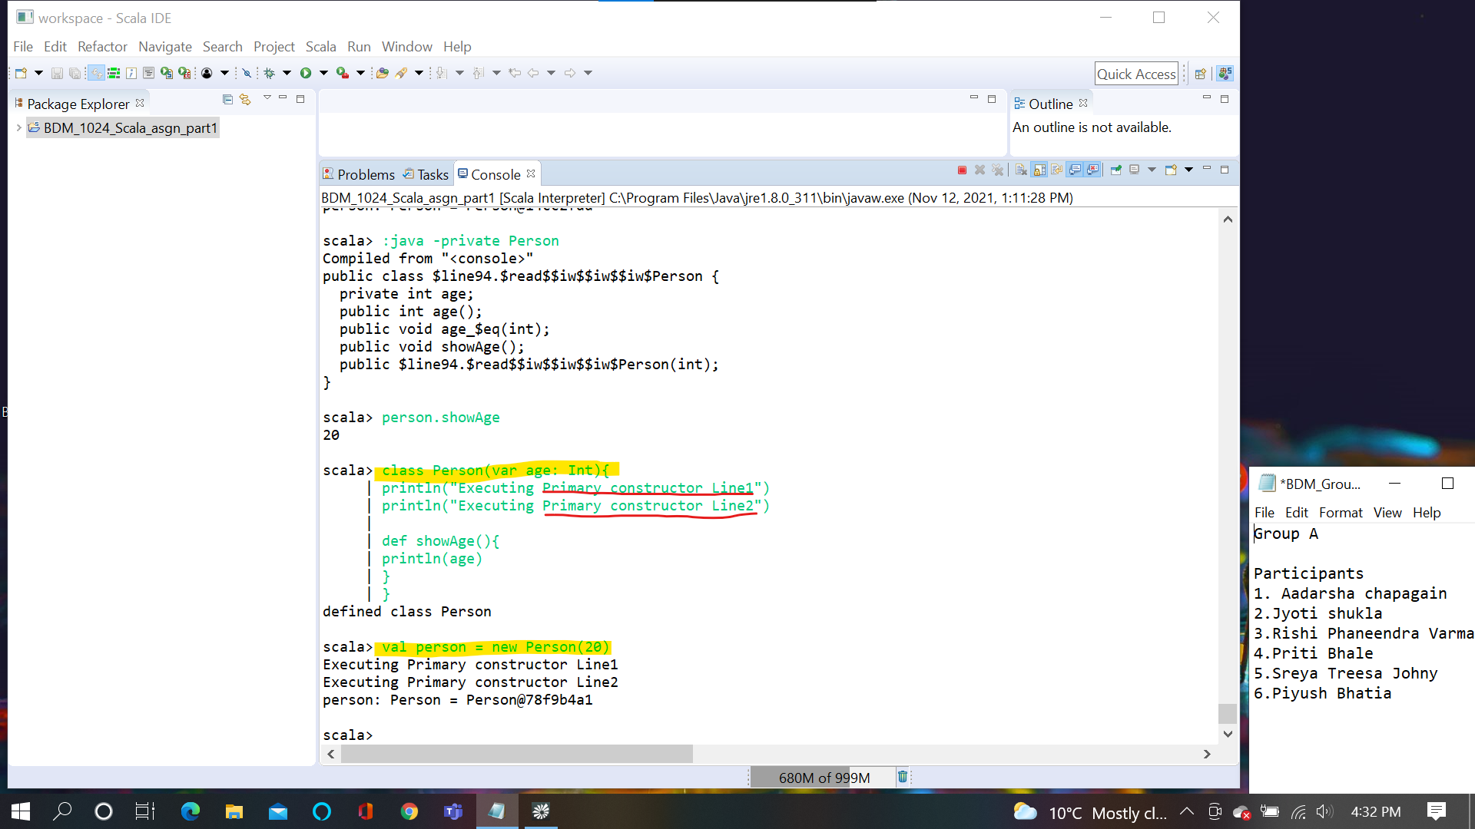

58 ,61,62,63 ,72,73 ,74,76

**Slide58:**

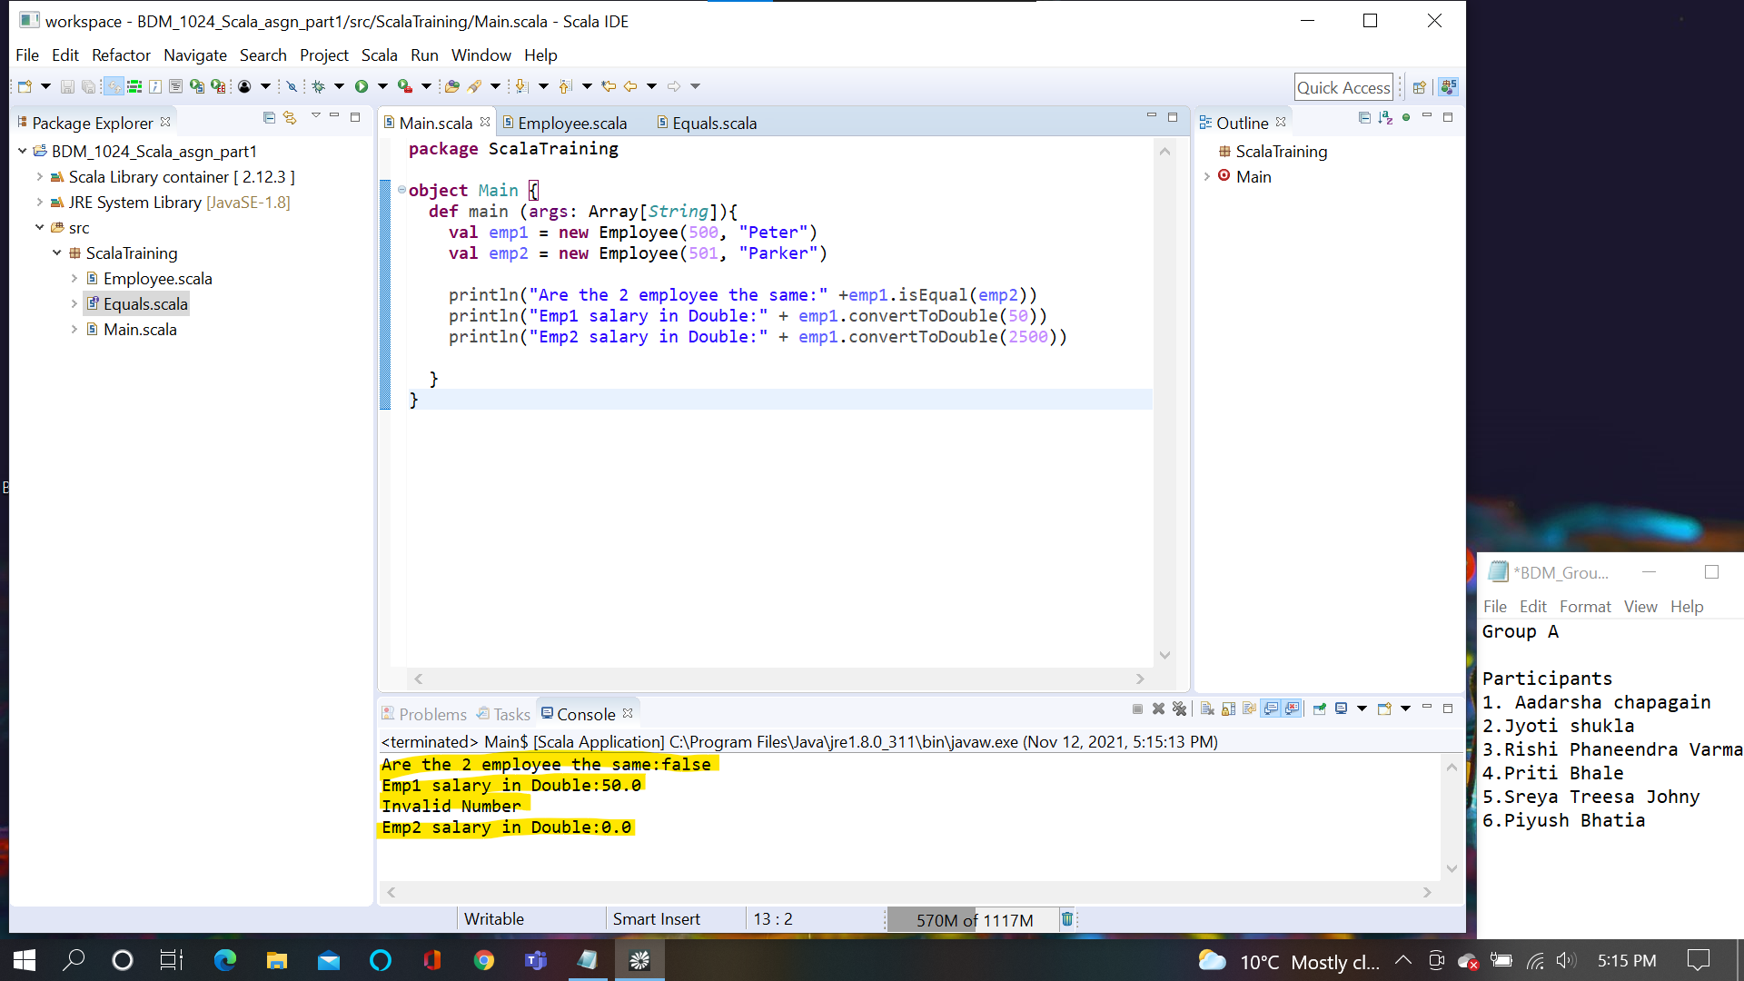

**Slide61:**

Calc and x are both variable but calc is pointed to a function.calc holds a function .

Look at the type of variable is “ ( ) => Double = <function0>” () means unit . () : this is a function which takes unit and returns a double.(calculatePI takes a unit and returns double)

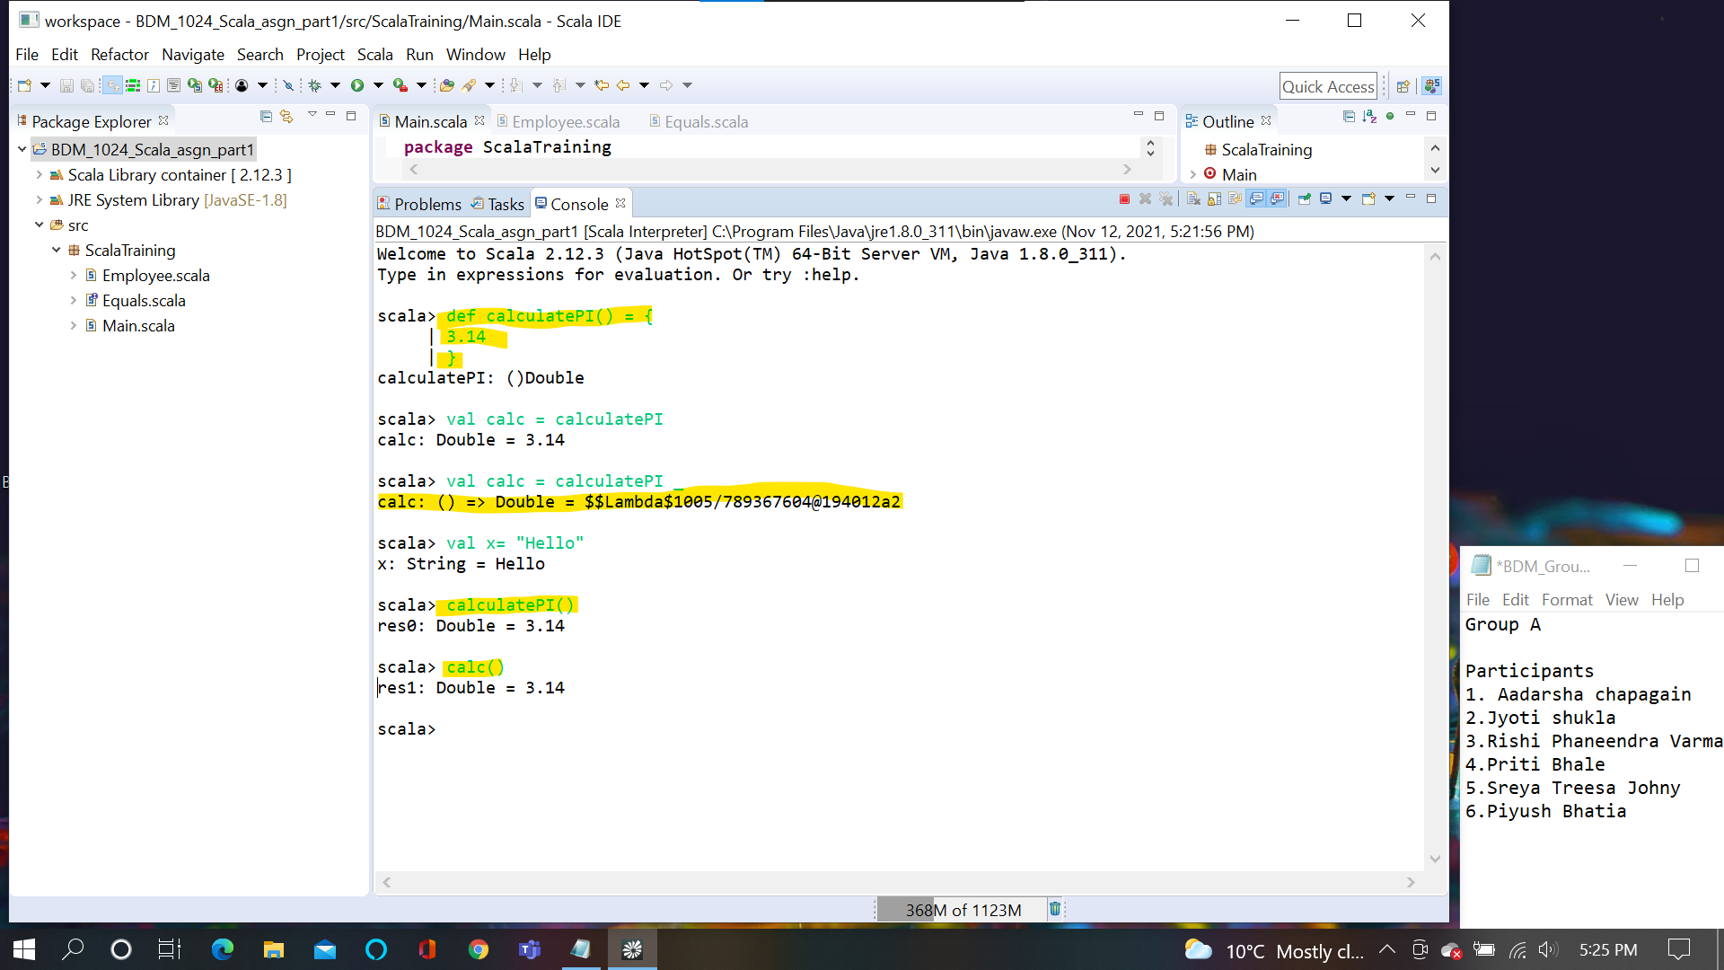

**Slide62:**

_ means current value in another word. it is basically designate the current element variable .Foreach is higher order function which accept another function

Function is supposed to take a variable but here foreach which is a function is taking another function

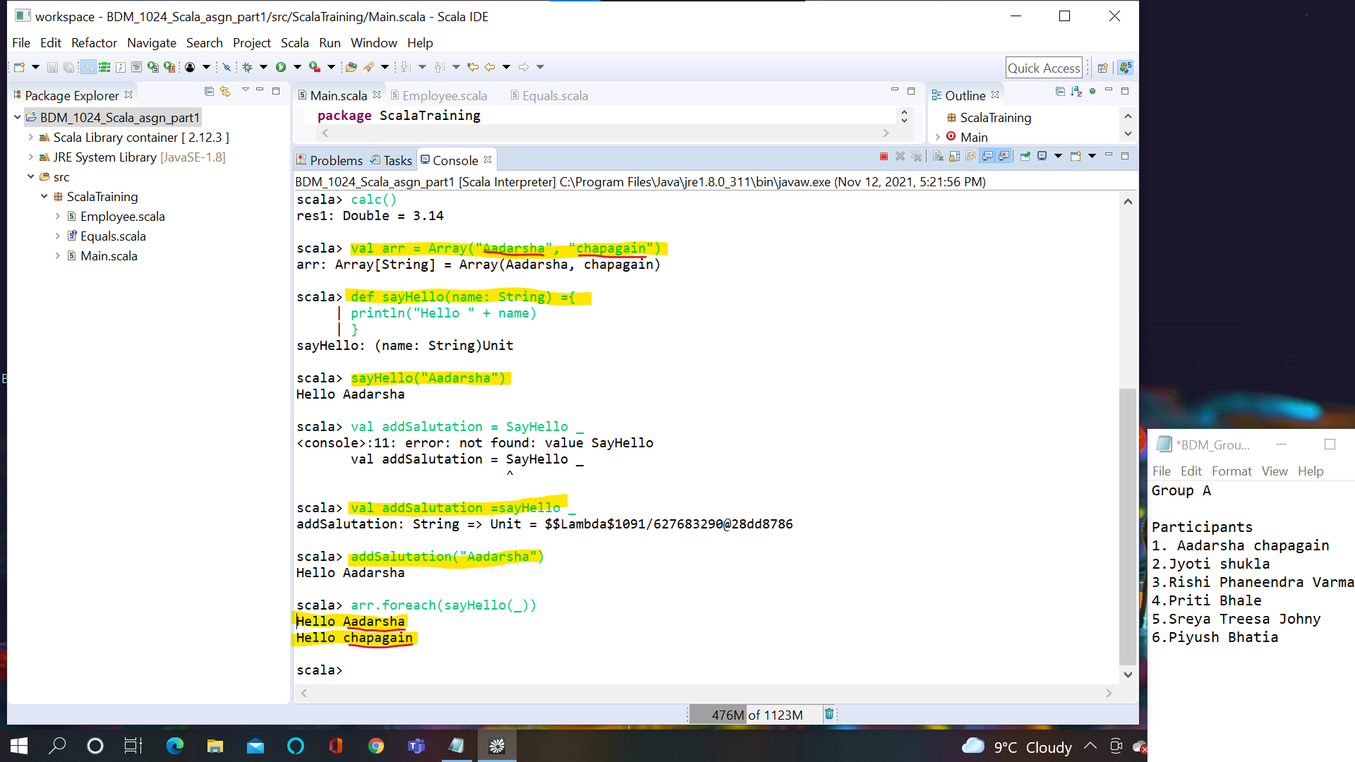

**Slide63:**

Map is another higher order function

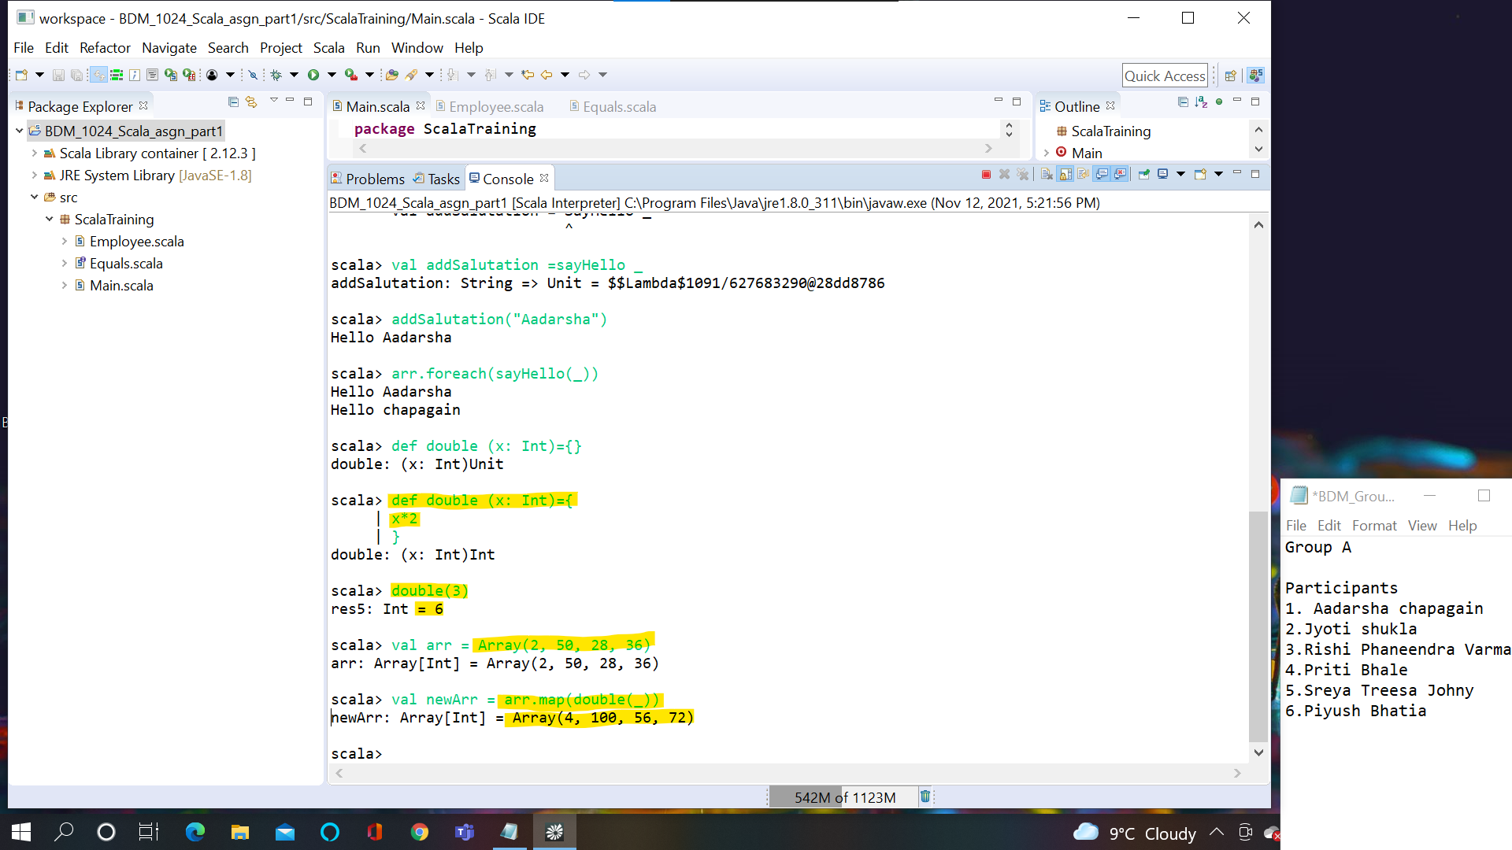

**Slide72:**

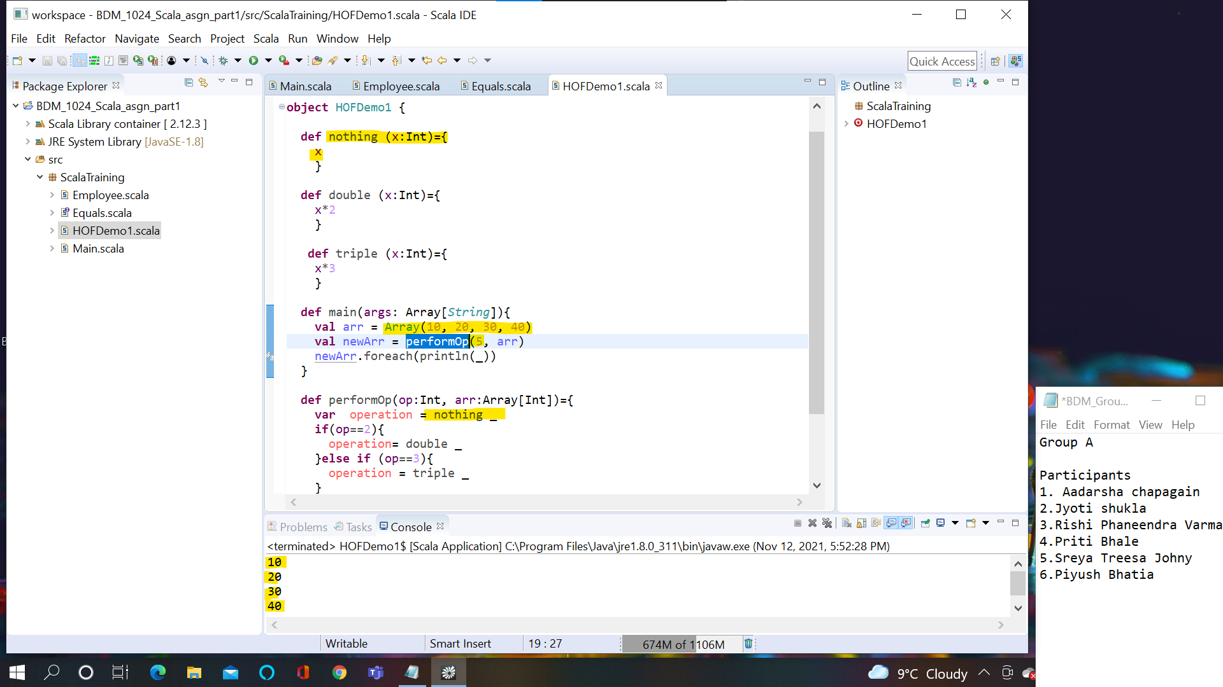

**Slide73:**

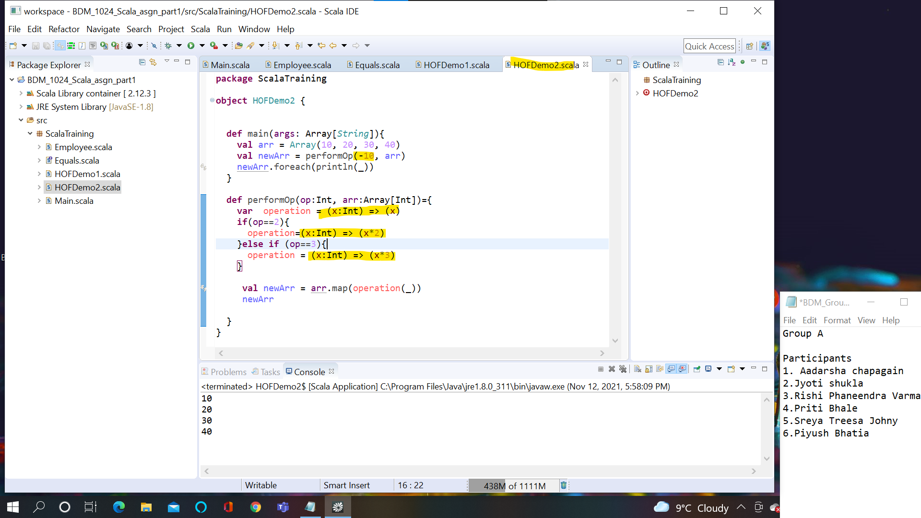

**Slide74:**

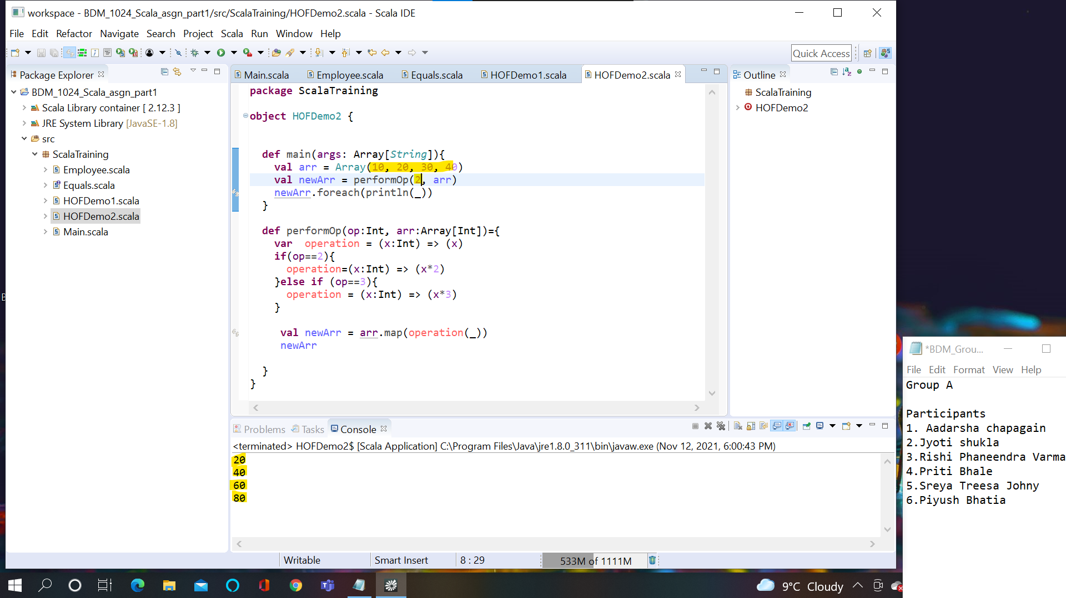

**Slide76:**

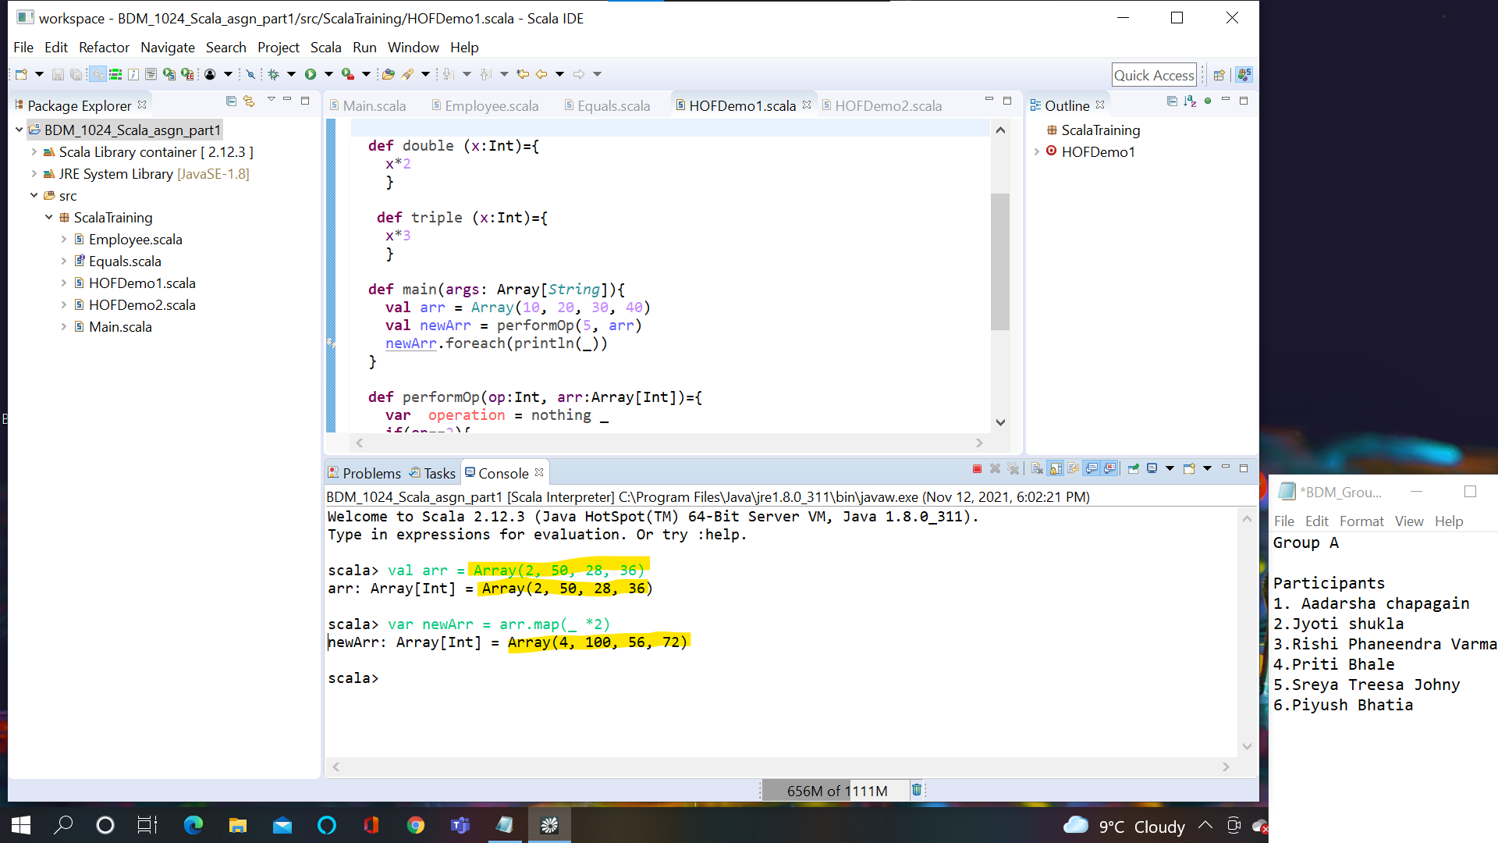

**Part 2 :Write a Scala code which can get data from Twitter and show in the console. Please upload your code too**

**object** FetchTwitterData {

**import** sttp.client3.quick._

**def** main(args: Array[*String*]){

**val** BearerToken = "<tokenfromtwitter>"

**val** UserName = "<twitterUserName>"

**val** TwitterEndpoint = "https://api.twitter.com/2/users/by/username/$UserName"

**val** GetResponse = basicRequest

.get(TwitterEndpoint)

.auth

.bearer(BearerToken)

println(GetResponse)

}

}